**At Geary Elementary Community School:**

***“We C.A.R.E.”***

**March 2017 http://geary.nbed.nb.ca**

**Storm Days**

**GEARY GAZETTE**

Many of the events we had planned over the past few weeks have had to be rescheduled or bumped to new dates. Our March parent page will reflect these changes. Please take time to note these changes in, “Important Dates to Remember” below. Our School-wide **Pink Shirt Day** is now **February 23rd**.

**Home and School**

The next meeting of the Home and School Association will be held in the school library on **Wednesday, March 15th at 6:00 p.m**. The Home and School has been very busy planning for the Spring Bazaar. This is the major fund raiser for the Home and School. If you have business contacts and are able to contribute we would welcome your show of support!  
   
The **Spring Bazaar Bingo** is being held on **Friday,** **April 21st at GECS in the cafeteria from 6:30 – 7:30 p.m. On Saturday, April 22nd, the Spring Bazaar will be held in the gym.** There will be a canteen operating in the cafeteria of the school.Doors will open at 8:00 a.m. This is a family oriented event! Come and enjoy the fun and the friendship!

**Sliding Party**

On Saturday, February 25th, the Home and School are planning to host a Sliding Party for families in our school community. Please come and enjoy sliding with your friends and family and enjoy a cup of hot chocolate or a hot dog. There will be a small charge for the refreshments but everything else is free. Please come out and enjoy the fun with your children.

**Fish Friends**

Our Grade Five class will, once again, be involved in raising Atlantic salmon in their classroom. Atlantic salmon are a species-at-risk. The Fish Friends program, sponsored by the Atlantic Salmon Federation, gives students an appreciation for this species. Salmon are given a start in a protected environment. These salmon will be released into nature in June, when they have reached the fry stage.

**Report Cards**

The second reporting period is fast approaching. Teachers have been collecting data on academic, physical and social/emotional areas of growth for each child. Report cards will be sent home on April 4th. Student-Led conferences will be held on Thursday, April 6th in the evening and the morning

of Monday, April 10th. If your child is struggling at this time or if you have any other concerns we

recommend that you take advantage of this conference date. We always look forward to

conferencing with you and your child.

**PSSC**

Your PSSC have reviewed the School Improvement Plan and Assessment Results from 2016-2017. The PSSC meets again on **Tuesday, March 28th** at 6:30. We welcome parents to attend.

**Geary Headstart Preschool Program Registration 2017-2018**

Date: **Wednesday, April 5th**

Time: **12:45-1:45**

Place**: Headstart Room – community use of school entrance.**

Needs: **Copies of Proof of Immunization, Birth Certificate, Medicare and $25.00 Registration Fee.**

**Note: Registration is not complete until all paperwork is filled out and registration fee is paid.**

Due to space, only 20 students can be in each program at one time. We are offering 2 programs for the 2017-18 school year – Monday & Wednesday from 8:30-12:30 or Tuesday & Thursday from 8:30-12:30.

Registration is open to all preschoolers from the Geary, French Lake, Haneytown and Waterville areas. Children outside these areas will be put on a waiting list.

The program is held at Geary Elementary Community School in the Early Years Center/Headstart Room.

For details and information call Bonnie McDonald-Lively (Coordinator) 449-2603.

***Vaccinations Protect Your Child***

**Diseases that were once common in childhood are now rare because of vaccines. Many of these diseases caused severe illness and sometimes death in children. Vaccinations given to infants, children and teens protect them against many of these serious illnesses. These vaccines can be given by your doctor, nurse practitioner or through Public Health clinics.**

In New Brunswick, parents are required to provide schools with an updated immunization record for their child.

* If your child is starting kindergarten or just entering school in New Brunswick, please provide the school with a copy of their immunization record.
* If you are not sure if your child has received all their vaccines or if you need a record of your child’s vaccinations, contact your doctor, nurse practitioner or local Public Health Office.
* Your child’s record should show proof of all their vaccinations required for their age, including the preschool booster.

*The influenza vaccine is also free of charge to all children and youth between 6 months and 18 years of age. The flu vaccine is available every year starting during the month of October. Flu can be a serious infection for children. Please contact your health care provider to ask about the flu vaccine for your child and family.*

Public Health can answer questions that parents may have. The Public Health Office can be reached in Fredericton and Oromocto area at 453-5200.

*Information is from Government of NB and Public Health Agency of Canada websites.*

<http://www2.gnb.ca/content/gnb/en/departments/ocmoh/cdc/content/immunization>. 

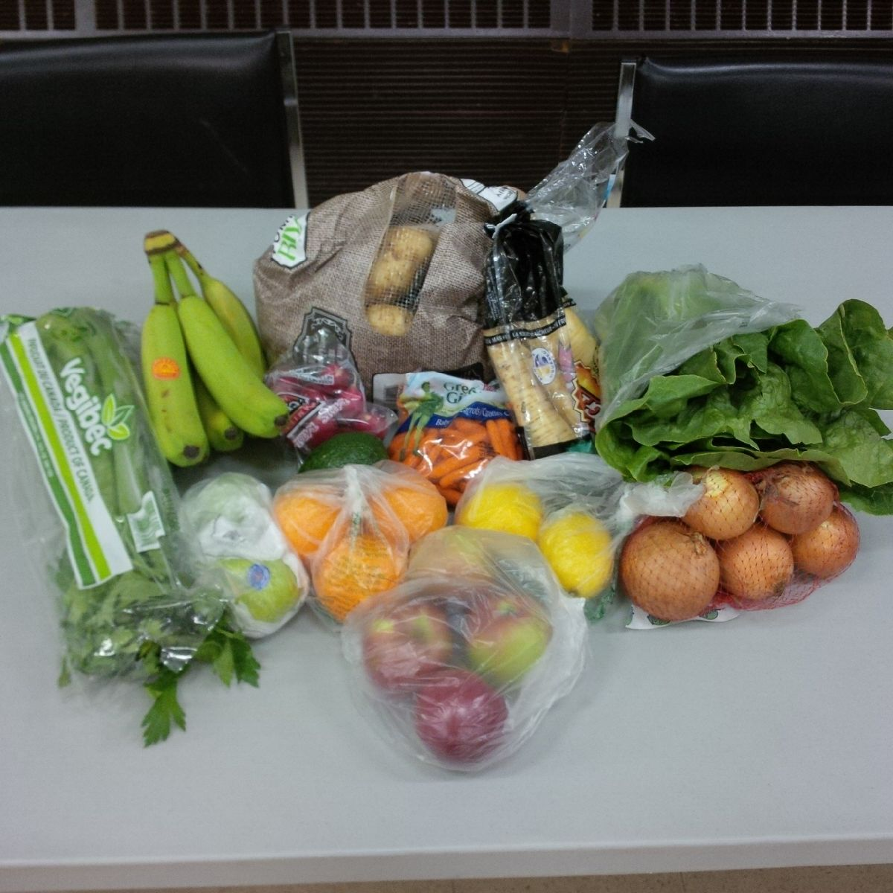

ALL THIS FOR $15! Available once/month

Contents vary monthly and savings are approx. $25/bag compared to retail prices for same items. Two bags/month may be ordered. Orders can be placed at Geary Elementary Community School any school day. Order deadline is usually 1st Wednesday of each month and pick-up date is usually 2nd Wednesday of each month. March break is an exception this year. Orders are due by Wednesday, March 8th and can be made at  
the school until Friday, March 3rd. Pick-up date is Wednesday, March 15th.

Orders can also be placed on Tuesday nights at Geary Lions Club or by contacting

Leola Langille, [stev446@nb.sympatico.ca](mailto:stev446@nb.sympatico.ca) or 444-1345

Program brought to Geary by the volunteers of Greater Geary Association in partnership with Geary Lions Club and Geary Elementary Community School.

**Community Food Smart:** a bulk food buying club for our communities

<http://www.communityfoodsmart.com/>

**Health Note - National Nutrition Month 2017**

By Fredericton and Upper Valley Horizon Public Health Registered Dietitians

March is Nutrition Month and in honor of this, your local Horizon Public Health Dietitians along with Dietitians of Canada are helping to support Canadians in taking the fight out of food. The slogan for the 2017 campaign is T*ake the fight out of food! Spot the problem. Get the facts. Seek Support.*

Eating should be joyful, not a source of everyday frustration and confusion. Try this three-step approach:

1. Spot the problem. Define what’s causing your fight with food first.

2. Get the facts. Use facts from credible sources to decide what needs to be done to solve the problem.

3. Seek support. Put the plan into action with support from a dietitian, family and friends.

Check out [www.NutritionMonth2017.ca](http://www.NutritionMonth2017.ca) to find all the resources. If you are looking for free apps to get you started, check out the “Get the Apps” link on this website. These apps are a convenient way to access dietitian expertise any time.

We plan to host a **Multi-Zone** presentation during the month of March. Multi-Zone is a fabulous program that teaches students, through physical activities, all about nutrition. Please be sure to give a great big Gator Welcome to Renee LeBlanc, while she is in our building facilitating this program.

**Library Boost**

Our school library has been fortunate enough to receive a grant from the Canadian Federation of University Women. The proposal for this grant stated that the money would be used to buy books which would enhance our students' exposure the cultures of Canadian Indigenous People. We are so grateful!

**Our Thanks**

We would like to acknowledge the generous support of Breakfast Club Canada, New Brunswick Breakfast for Learning and our local Oromocto Superstore Pharmacy. We couldn’t do what we do, without your financial assistance.

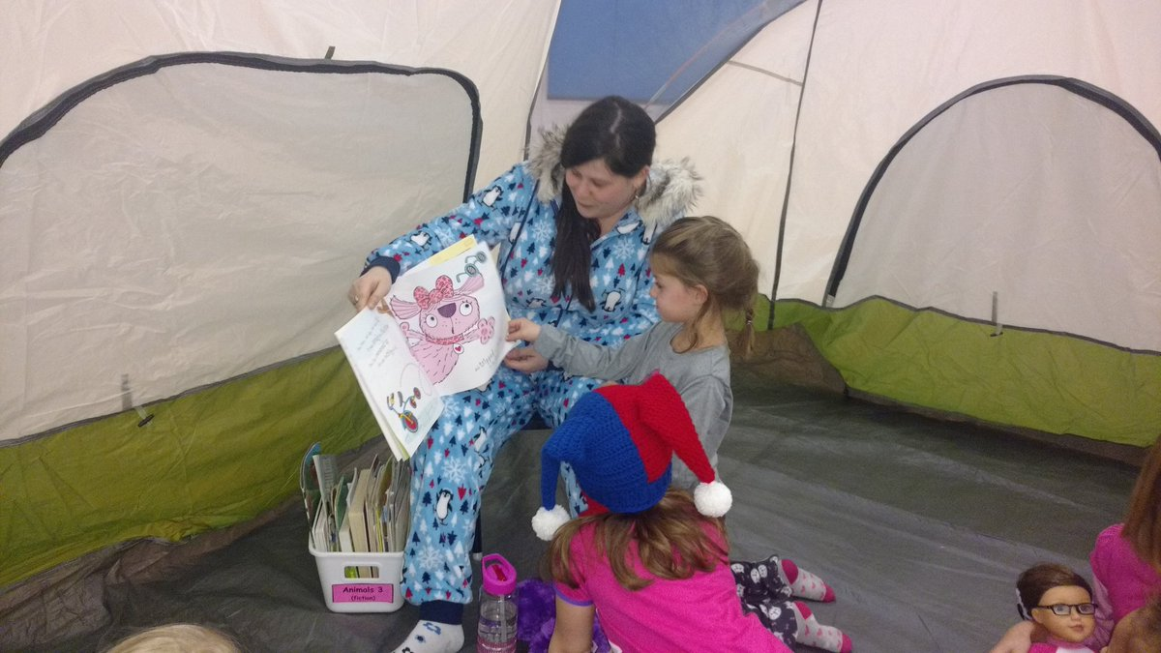

***Storytent is a huge success at GECS!***

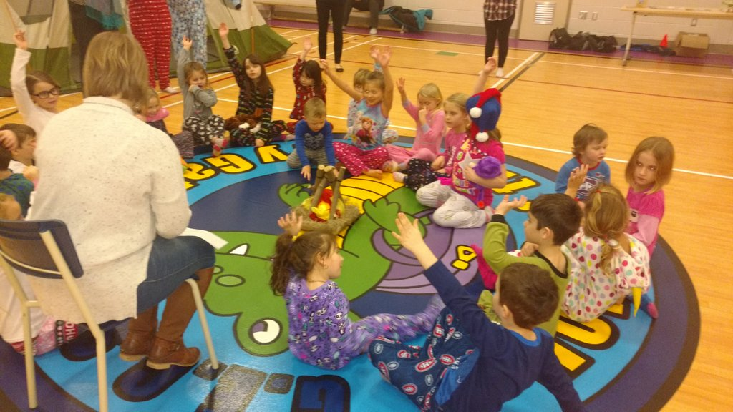

Storytent ends with a campfire and sing song!

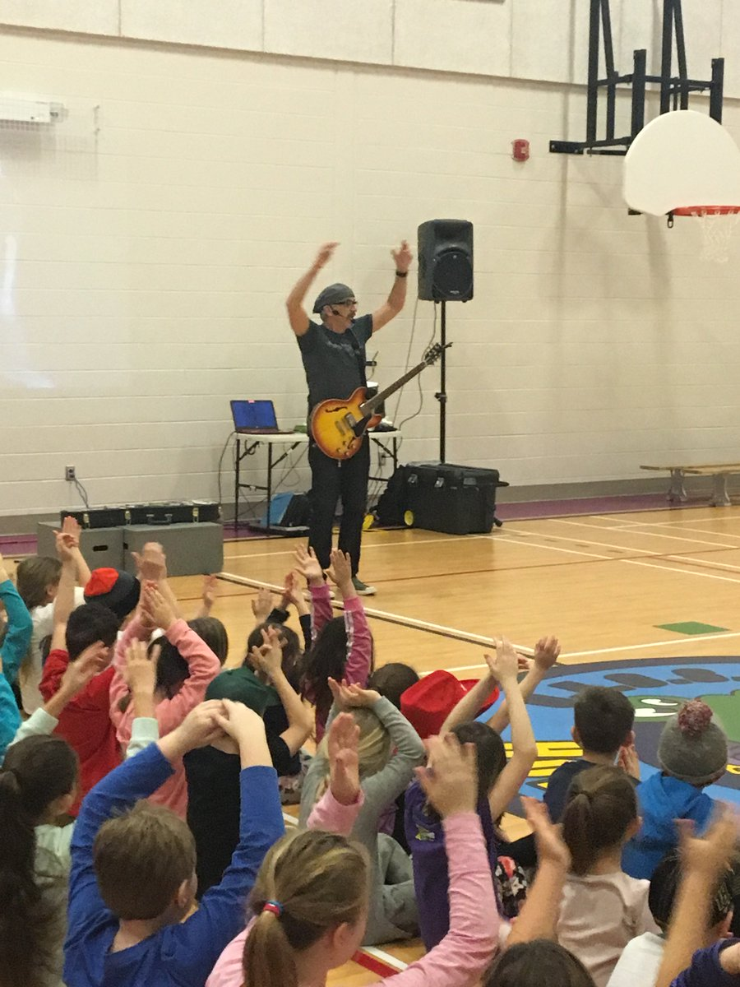

Our Bilingual Learning Environment Plan included a concert with Roland Bibeau. BEEBO was AMAZING!

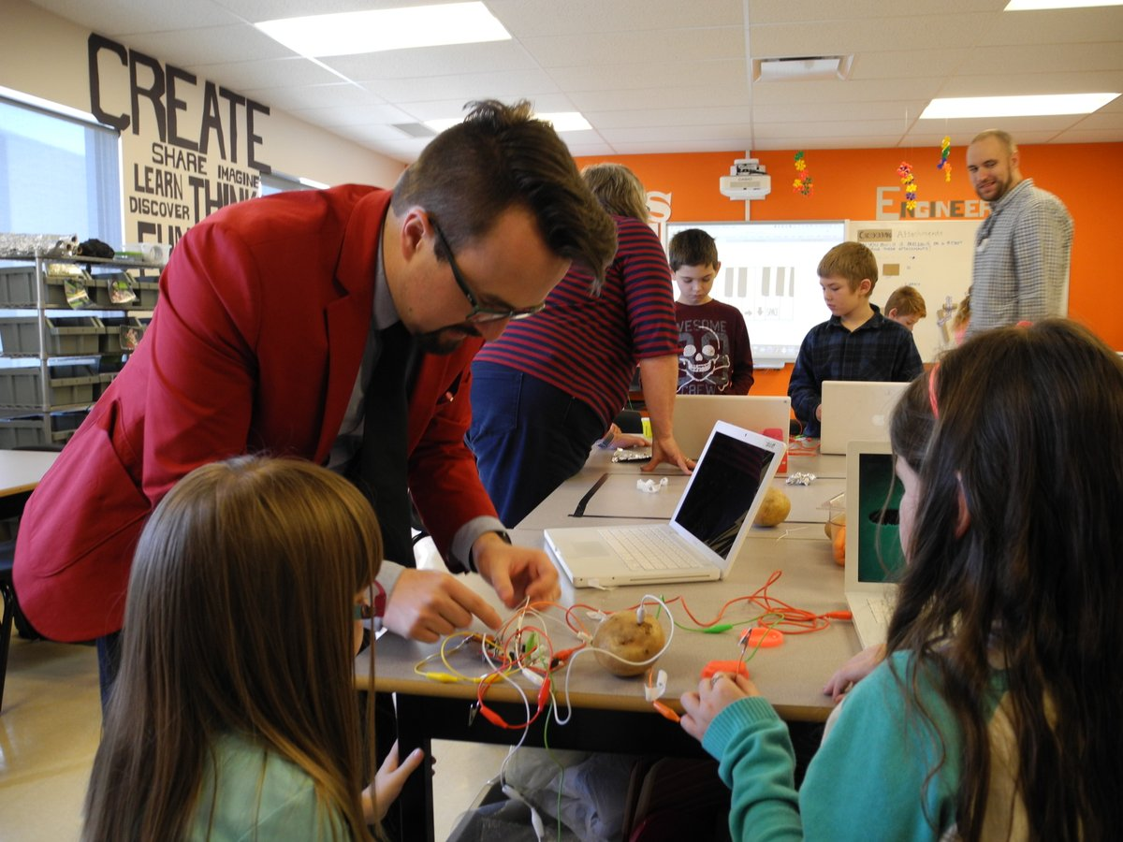

Hands on learning in the Makerspace with MakeyMakey fun! Thank you to Brilliant Labs for supporting us with both human and other resources. Our Tech Leads, Janice Shaw and Wendy Thomas are always up for a challenge. Thank you!

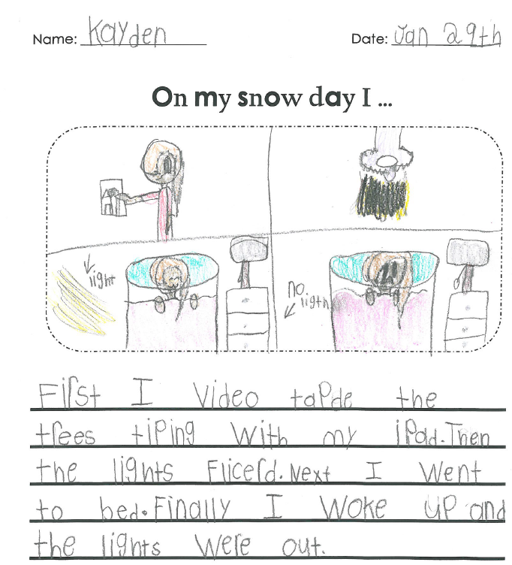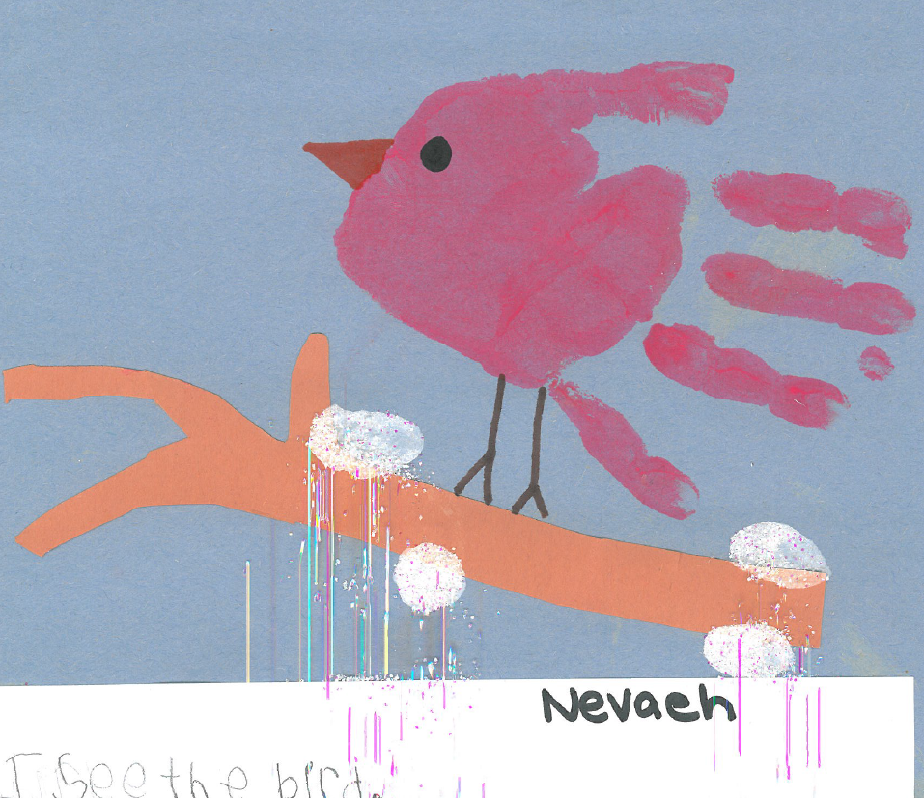

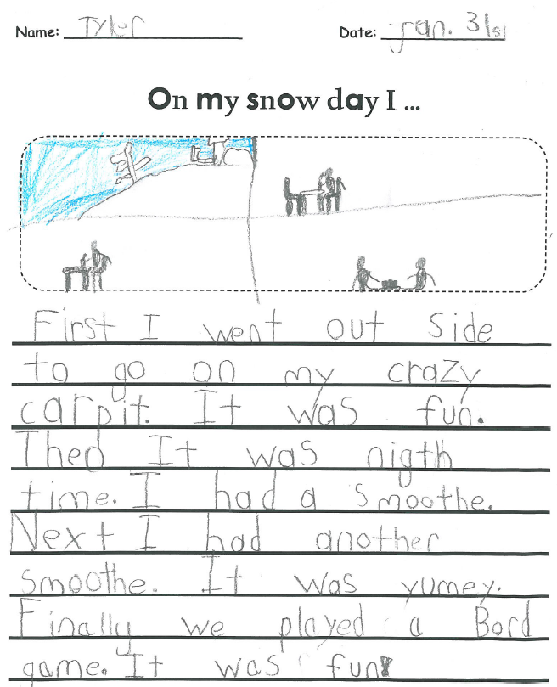

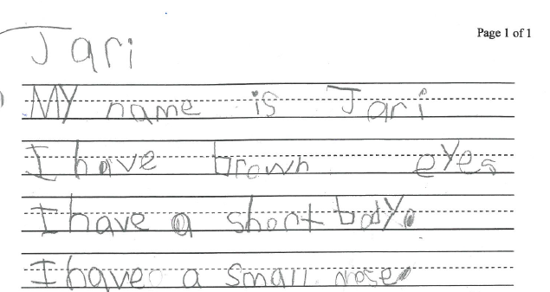

**Before and After School Childcare**

There is one space available in our childcare program. Please call Bonnie Lively at: 449-2603 if you are interested. The cost is 55.00 per week and includes PL Days.

**Staff Appreciation**

**Thank you so much for the delicious treats and the special trimmings around the school for our staff appreciation week. We know we are well loved by this community and we wouldn’t want to work anywhere else. Coffee and muffins along with baked goodies from our Home and School and a delightful breakfast from the Geary Baptist Church this morning are all reminders of the kindness and cooperation we see each and every day!**

**It is a wonderful world!**

|  |  |
| --- | --- |
| Important Dates  To Remember | |
| Tuesday,  February 21st | NB Tennis support learning in gym  **Hot Lunch orders accepted until this date** |
| Wednesday,  February 22nd | **National Pink Shirt Day**  Wear pink today and tomorrow! |
| Thursday,  February 23rd | **PINK SHIRT DAY/Friendship Day** (wear pink and if you don’t have pink, wear white!)  Anti-bullying Awareness activities with OHS students |
| Friday,  February 24th | Professional Learning Day  No School for Students  **UNB Men’s Hockey Event**  **(Refer to letter)** |
| Saturday,  February 25th | **Sliding Party** at the school  1-3 p.m. |
| Monday,  February 27th | Field Trip to Playhouse  **Moon Mouse**  Mrs. Doherty returns K/1 |
| Tuesday,  February 28th | TNB visits – **Damsel in Distress**  Headstart – Grade 5 |
| Wednesday,  March 1st | 100 Days of School Celebration! |
| Friday,  March 3rd | **Community Food Smart**  Order deadline at school |
| March 6th  – 10th | **MARCH BREAK**  **No school** |
| Monday,  March 13th | **Black History Month**  **Haruka Kudo visits**  K-2 EST Numeracy returns  **Mrs. Crowhurst returns (4)** |
| Wednesday,  March 15th | **Community Food Smart**  Pick Up  Home and School Meeting 6pm |
| March 17th | **Happy Saint Patrick’s Day** |
| Tuesday,  March 28th | **PSSC Meeting** |
| Wednesday,  April 5th | **Headstart Registration 2017-2018** |
| Tuesday,  April 4th | **Report Cards – Term 2** |
| Thursday,  April 6th | **Student-Led Conferences**  **(evening only)** |
| Monday,  April 10th | **PL day – no school for students (interviews in morning only)** |
| Wednesday,  April 12th | **Writer in School Visits- Diane Carmel Leger** |
| April 14 - 17 | **Easter Break** |
| Friday,  April 21st | Children’s Bingo |
| Saturday,  April 22nd | Spring Bazaar |
| Friday,  April 28th | Professional Learning Day  **NO SCHOOL** |